Assignment 5 : Docker
One Git repo
Three branches:
- main (or master)
- 2026Q1
- 2026Q2
Jenkins Master (JM)
3 Jenkins Slaves
Each slave has Docker installed Use docker volume
Deploy:
- Slave1 → main branch
- Slave2 → 2026Q1
- Slave3 → 2026Q2
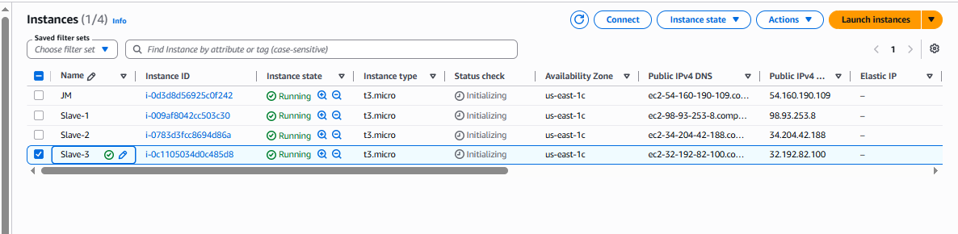

Install java in all machine :
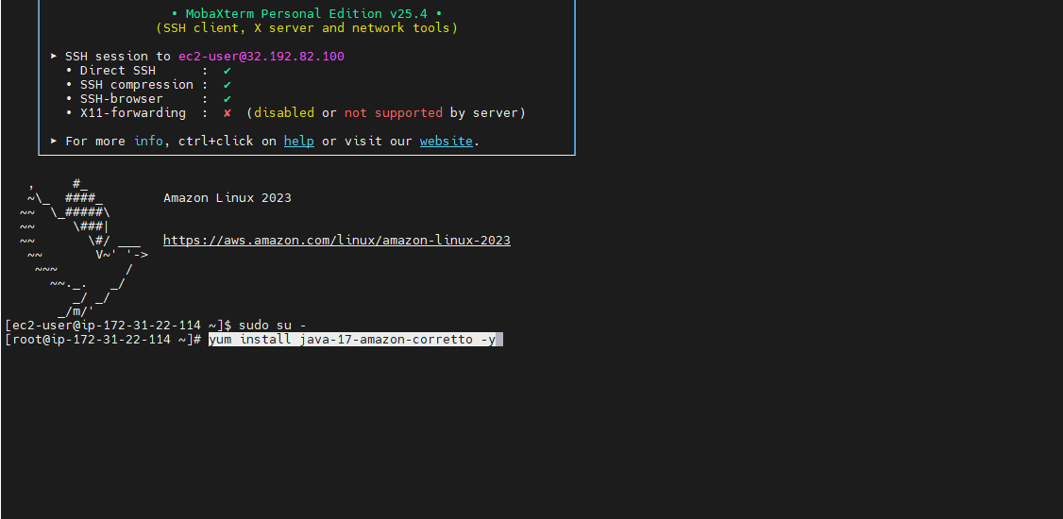

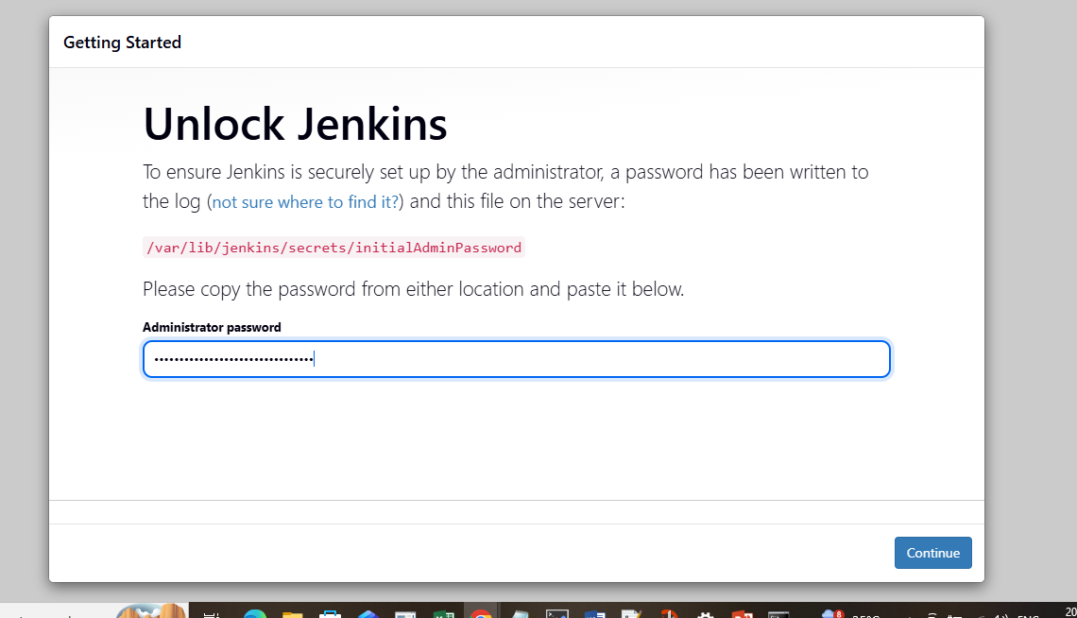

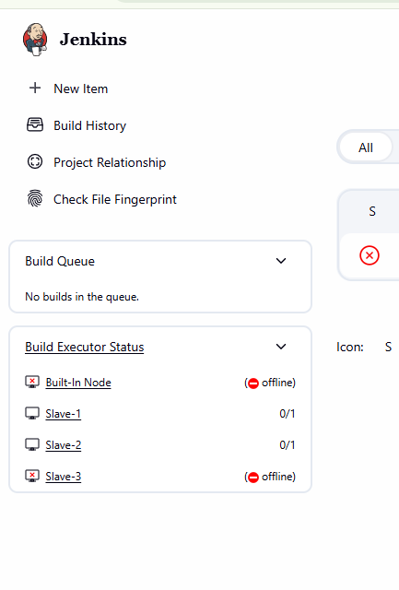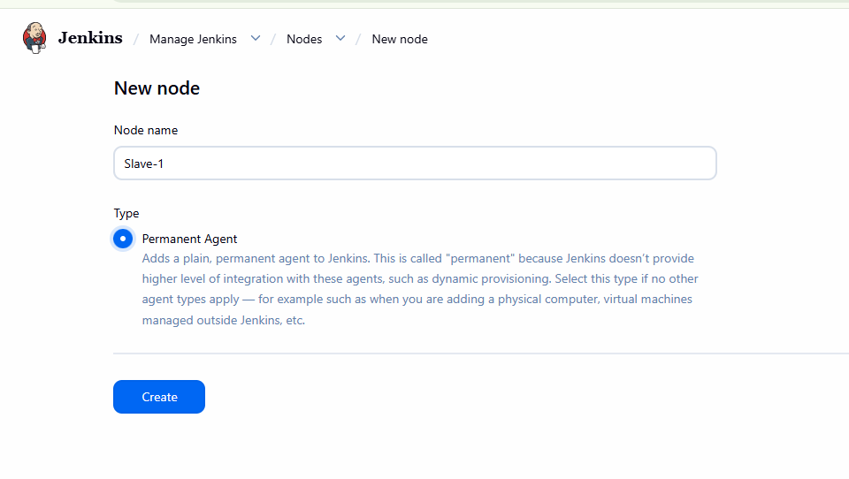

Same for Slave 2 and Slave 3 and make agent online after launching

Create one job with pipeline and mention below script in pipeline in config
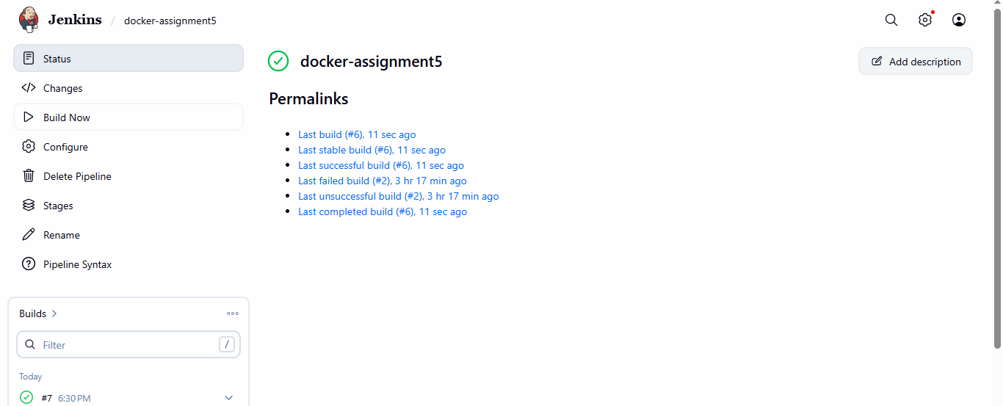

& check behaviour in slave server
Slave : 1
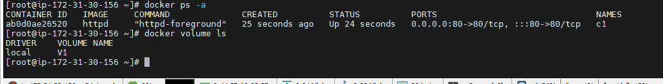
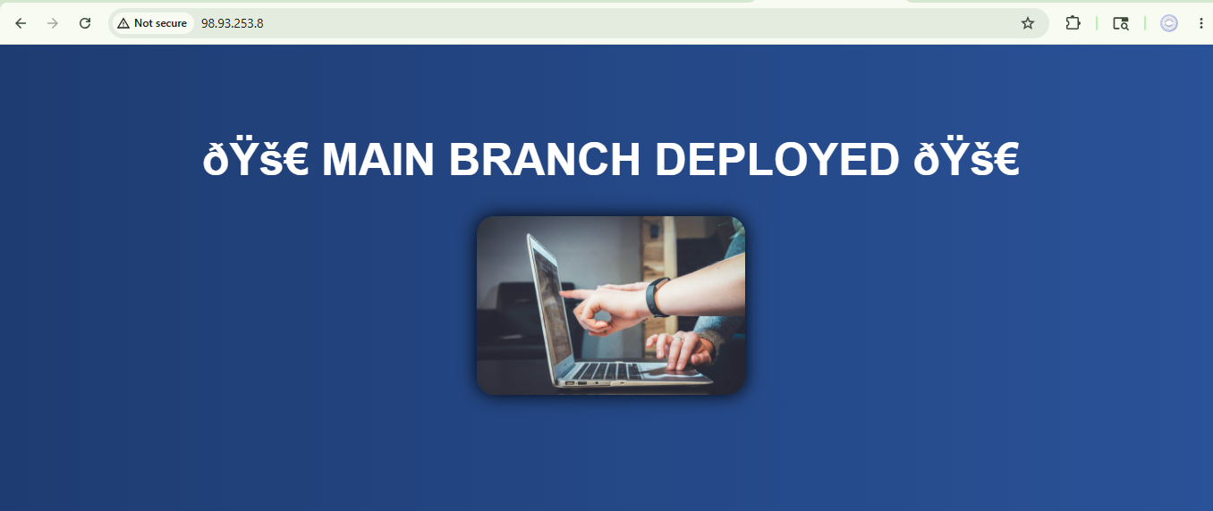
Slave :2
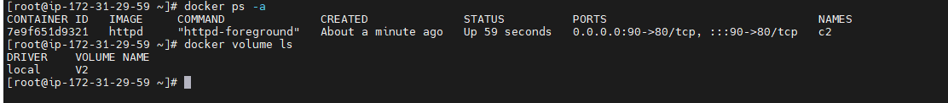
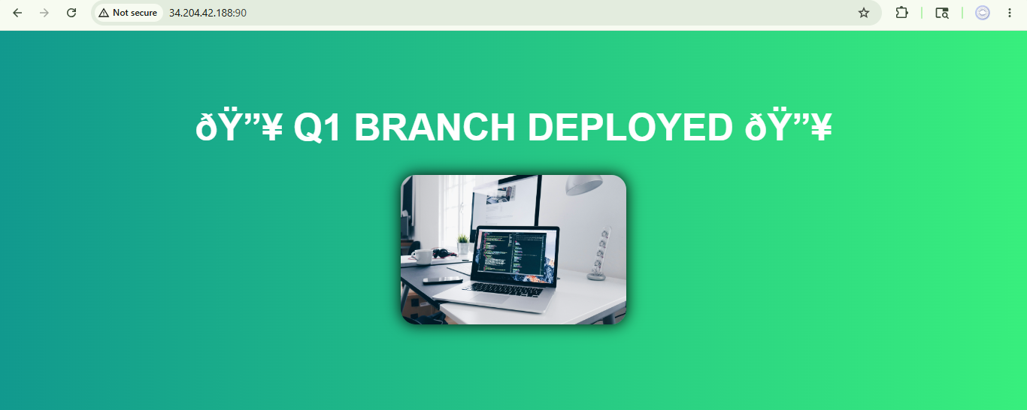

Slave 3:
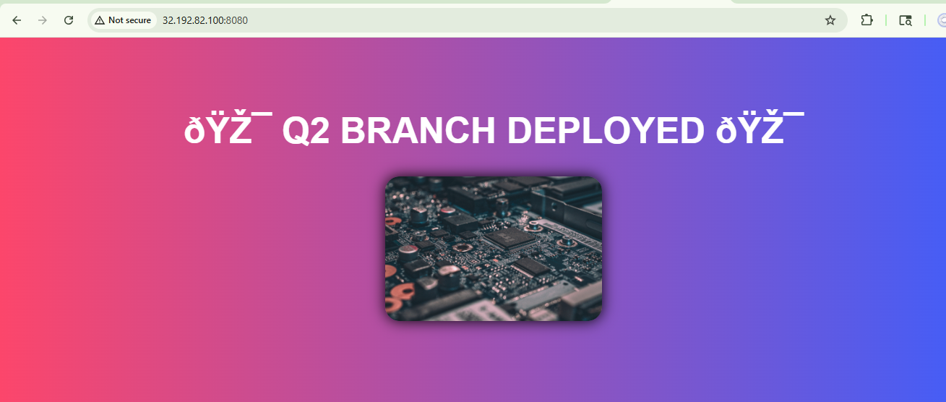

Syntax :

pipeline {

agent none

stages {

// ================= SLAVE 1 =================

stage('Deploy MAIN on Slave1') {

agent { label 'Slave-1' }

steps {

sh '''

rm -rf repo

git clone -b main https://github.com/Pallavi-250598/Repo-1.git repo

docker rm -f c1 || true

docker volume create V1

docker run -dit --name c1 -p 80:80 -v V1:/usr/local/apache2/htdocs httpd

docker cp repo/. c1:/usr/local/apache2/htdocs/

'''
}
}

// ================= SLAVE 2 =================

stage('Deploy Q1 on Slave2') {

agent { label 'Slave-2' }

steps {

sh '''

rm -rf repo

git clone -b 2026Q1 https://github.com/Pallavi-250598/Repo-1.git repo

docker rm -f c2 || true

docker volume create V2

docker run -dit --name c2 -p 90:80 -v V2:/usr/local/apache2/htdocs httpd

docker cp repo/. c2:/usr/local/apache2/htdocs/

'''
}
}

// ================= SLAVE 3 =================

stage('Deploy Q2 on Slave3') {

agent { label 'Slave-3' }

steps {

sh '''

rm -rf repo

git clone -b 2026Q2 https://github.com/Pallavi-250598/Repo-1.git repo

docker rm -f c3 || true

docker volume create V3

docker run -dit --name c3 -p 8080:80 -v V3:/usr/local/apache2/htdocs httpd

docker cp repo/. c3:/usr/local/apache2/htdocs/

'''
}
}
}
}

